**Lab_** **Day -** **15 (Set)**

1. Write a Python program to Get Only unique items from two sets.

Input: set1 = {10, 20, 30, 40, 50} set2 = {30, 40, 50, 60, 70}

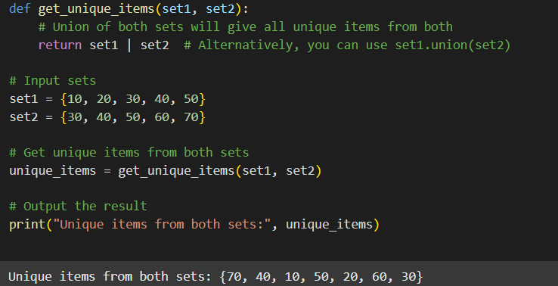

2. Write a Python program to Return a set of elements present in Set A or B, but not both. Input: set1 = {10, 20, 30, 40, 50} set2 = {30, 40, 50, 60, 70}

